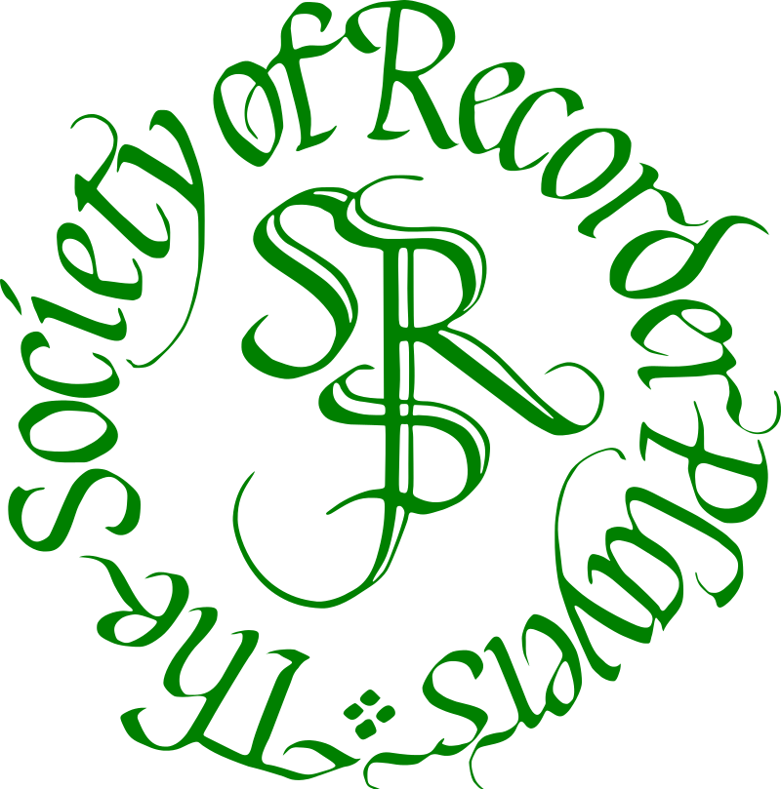
THE SOCIETY OF RECORDER PLAYERS
President: Jonathan Dove
Registered Charity no: 282751 (England/Wales); SC038422 (Scotland)

ESSEX BRANCH
NEWSLETTER –AUGUST 2018

Meetings are held at St. George's Church Hall, Ongar Road, Brentwood, CM15 9HR, usually on the first Saturday of each month (except August) 2.30 - 5.15 pm.

1 September
‘SRP Essex Branch 40th birthday party, a session for present members and invited guests only’ with guest conductor IAN WILSON

Our AGM will take place on October 6th, this will include a discussion of our questionnaire and a call for new candidates for the committee. We will also have a music sale.

October 6th
Phillips | Pavan & Galliard 'Paget' | SATTB | LPM EML104
Bach | 6 Chorale Preludes | SATB | Oriel OL127
Beethoven | Allegretto, Symphony No.7 | SATB | Polyphonic Pub.
Vaughan Williams | Bushes and Briars | TTBB (SSAA) | ms
 | Autumn magazine insert
November 3rd
Attwood | Dirge for Nelson's Funeral | SAATB | Hawthorns RS110
Handel | O Lovely Peace | SSATB | ms
Scheidt | O Nachbar Roland | SSATB | Oriel OL158
Isaac | A La Bataglia | ATTB | LPM AN1

We have a Facebook page! Join the group by searching for The Society of Recorder Players – Essex Branch

DATES FOR YOUR DIARIES
Further branch meeting dates: 1 December Christmas party - afternoon session with mince pies.
5 January 2019, 2 February, 2 March, 6 April with visiting conductor Vincent Tumosas, 4 May, 8 June (to allow for church event on 1 June), 6 July.

SUBSCRIPTIONS
The new rates for 2018/2019 will be discussed at the AGM in October. The new agreed rates will become payable after this date. Please by prepared to pay by cheque or Bank Transfer, not cash.
Proposed Subscription rates are Adult £40, Household £67.50, Life member £15, Student £15. Please pay by bank transfer if possible (sort code 20-12-21, account no 50834602, reference ‘your surname’). If paying by cheque, please make cheques payable to ‘The Society of Recorder Players’ and post to the Treasurer (Judith Underwood, 27 Brentwood Place, Brentwood CM15 9DN).

Other musical event you might like:
Ann and Steve Marshall playing days and courses (ASRE=Ann and Steve Recorder Events)
See www.mayhill.co.uk
Mulitchoir Playing Day for SRP members. 2 March 2019 Aston Village Hall near Stevenage, Herts.
Conducted by Steve Marshall and Helen Hooker

3 March 2019: Aston Village Hall near Stevenage, Herts:
Performance by METRO (Mellow Tones Recorder Orchestra). This is Helen Hooker’s eight foot orchestra.
If you want to join METRO please contact Helen@helenhooker.co.uk
Data Protection
Because the Society prepares its membership list on a computer but currently uses that list only for communicating with members the Data Protection Act 1998 does not apply to the list. The only personal information held by the Society is that which appears in the membership list. The list is distributed only to members of the Society for personal use and is not used or distributed by the Society or Branches for any commercial or other purpose.

BRANCH MUSIC LIBRARY

We have an extensive music library which we need to find a new home for – can anyone suggest a suitable location? It needs to be in or near Brentwood so that it is accessible when we need it for meetings, and be clean, dry and secure. This will be discussed during the AGM.

Bass recorder: The branch has a bass which is available for members to borrow, either to play at a meeting or to take home to practise. Please contact Madeline if you would like to borrow it.

VISITORS
Visitors are welcome to make 3 visits per year, after which we hope they will become members of the branch. Children aged 11-14 may attend 3 meetings as visitors, provided they are accompanied by an adult member of the branch. A member should bring only one child visitor at a time. Subject to the discretion of a committee member, children may become junior members of the branch. They must be accompanied by an adult member at all times. They must be able to play treble or tenor as well as descant.

Child Protection Policy
Whilst most members of the SRP are adults, the Society recognises its responsibilities to ensure that when children are included in any of its activities their safety is explicitly considered. To this end, people organising such activities for or including children must ensure that a child is not left alone with a single adult and that no lessons, where a child is left alone with an adult, are organised for children as part of an SRP activity. Occasionally SRP members are asked to recommend recorder teachers for children. If they pass on the names of teachers they will make it clear to parents that :
(1) the SRP takes no responsibility for the quality of any such teacher
(2) the SRP is not able to comment on whether or not the teacher has been DBS checked.

OFFICERS & COMMITTEE 2018/19
Honorary Chair anniversary year Marion Panzetta 01277 216093
Musical Director Madeline Seviour 020 8553 5940
Treasurer Judith Underwood 01277 231081
Secretary Annelies Wing 01992-573383
Librarian Christine Minns 01277 212379
Committee member Janet Holt 01277 213128
Committee member Caroline Saul 01371 873211

www.srp.org.uk email essex@srp.org.uk (branch secretary)

