Piers Adams Masterclass
Kea Church 19.10.13
Students from Richard Lander School took advantage of an exciting opportunity to work with the world renowned recorder player Piers Adams. This event was supported by the Society of Recorder Players, Cornwall Branch.
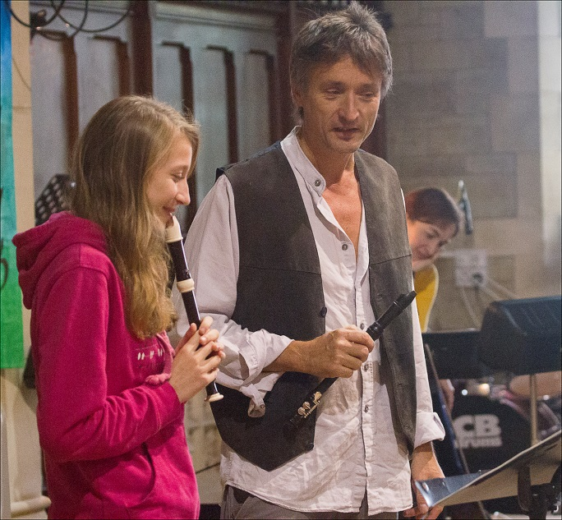
Piers Adams guided students through their performances giving them advice and ideas about how to improve their playing technique. Naomi Lynham played a modern, energetic piece titled Mesmeralda, which she attacked with confidence and accuracy. Piers was very helpful in suggesting ways to get the energy of the piece across to her audience. He also suggested that she didn’t bite her thumb nail as this was preventing her from playing the top notes of the piece clearly!
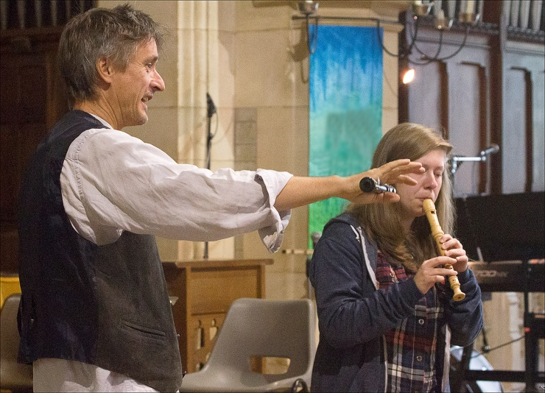

Yselkla Hall played the second movement of the Sammartini Concerto in F. Yeslkla communicated very well with her audience and received guidance on how to improvise a cadence.
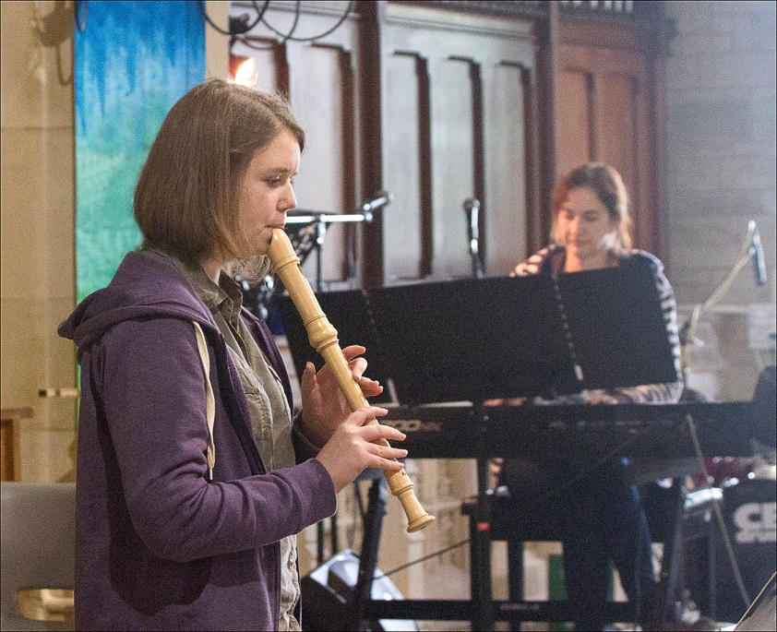
We were then treated to the slow movement from the Sonata in A minor by Handel, performed by Fiona Chegwidden. Fiona played with confidence and Piers commented on her sense of style and shape of her notes.

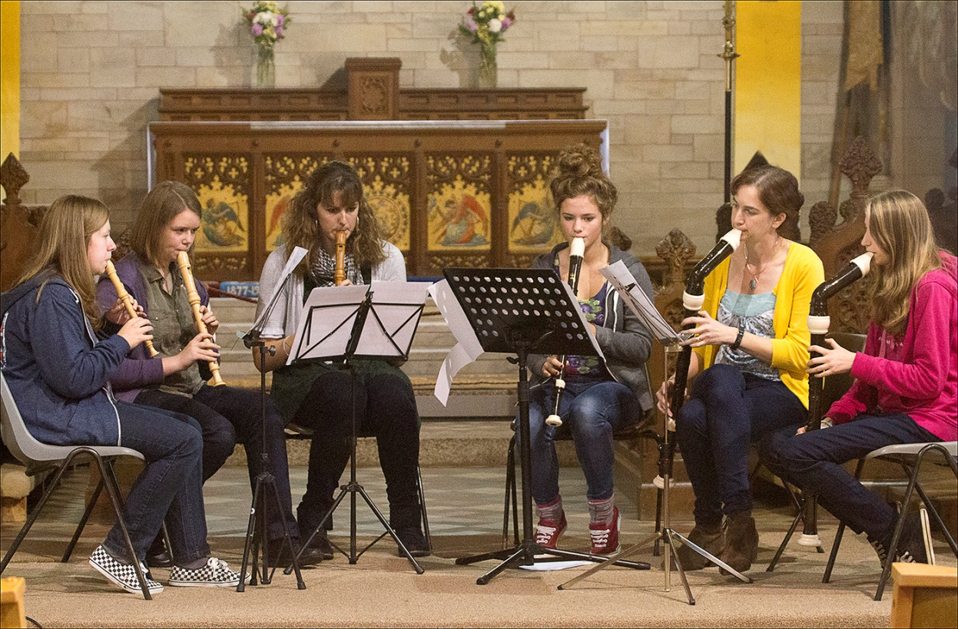
Two ensembles took part The Dolce Consort and the Wheal Jane Players. The Dolce Consort performed the first movement of a piece written for the group by Cornish composer Russell Pascoe.

It was interesting to hear how Piers approached learning the complicated rhythm pattern that the piece starts with.
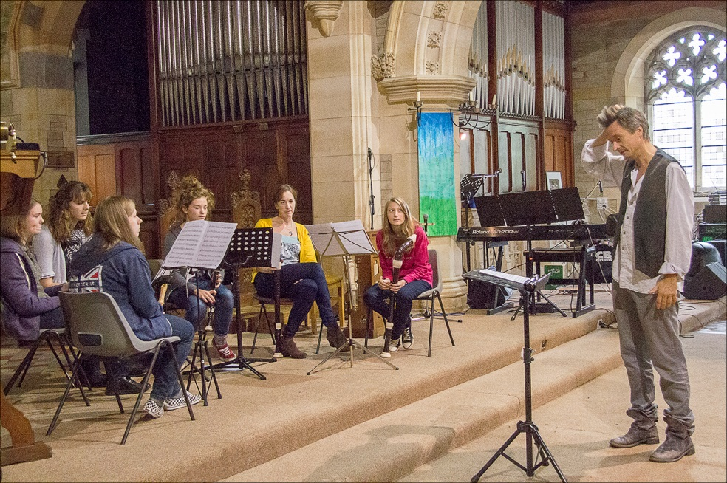
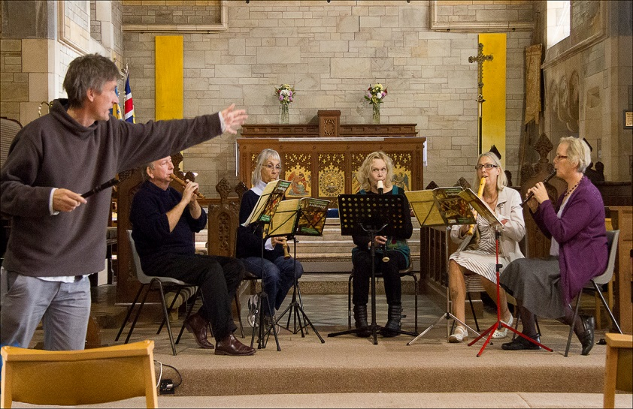
The Wheal Jane Players then performed a more traditional French piece.

Towards the end of the morning everybody had a chance to work with Piers Adams. The Cornish SRP members grabbed their recorders and took part in a massed playing session. 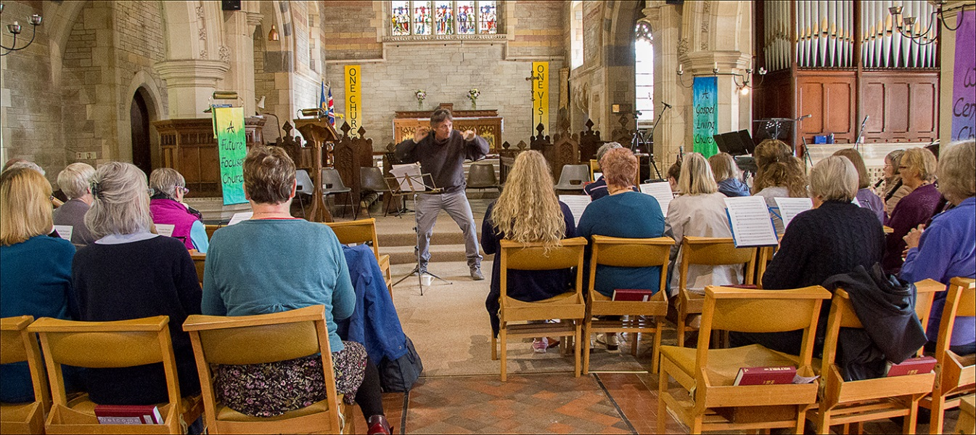
They played three short pieces and concentrated on making a better sound on each note. It was remarked that the difference in sound was immediate! Piers Adams was a great inspiration and encouraged all of the people present to keep rehearsing. It was a very informative and enjoyable morning. Congratulations to all those who took part.
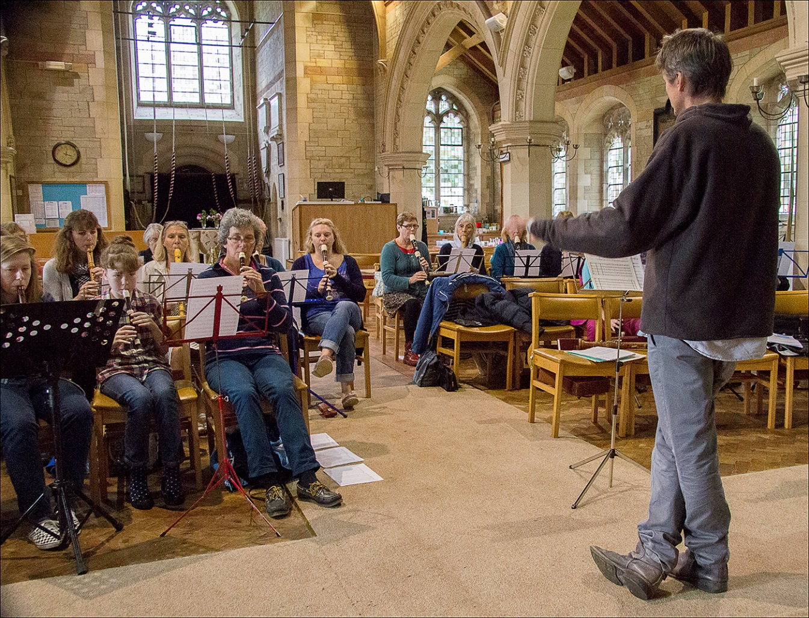

These photographs are © Margaret Hocking ARPS (bosrowynek@btinternet.com)

