Playing Day with Sarah Whomersley 21st October 2023
Please fill in your details below
Name:
Address:
PostCode:
Tel No:
Email:
Please indicate one option:
Somerset SRP member £10.00
Visiting SRP member £16.00
Visitor £16.00
Full Time Student or
Under 18yr Free
Please complete the form and email or post to:
Sue Walker email: suewalker30@yahoo.co.uk
Please pay preferably by bank transfer to:
Society of Recorder Players Somerset Branch
Sort code: 60-23-32 Acc No: 81468180
or by cheque made payable to:
‘Society of Recorder Players Somerset Branch’
and forward with your application form
If you have any problem please contact Sue at the above email
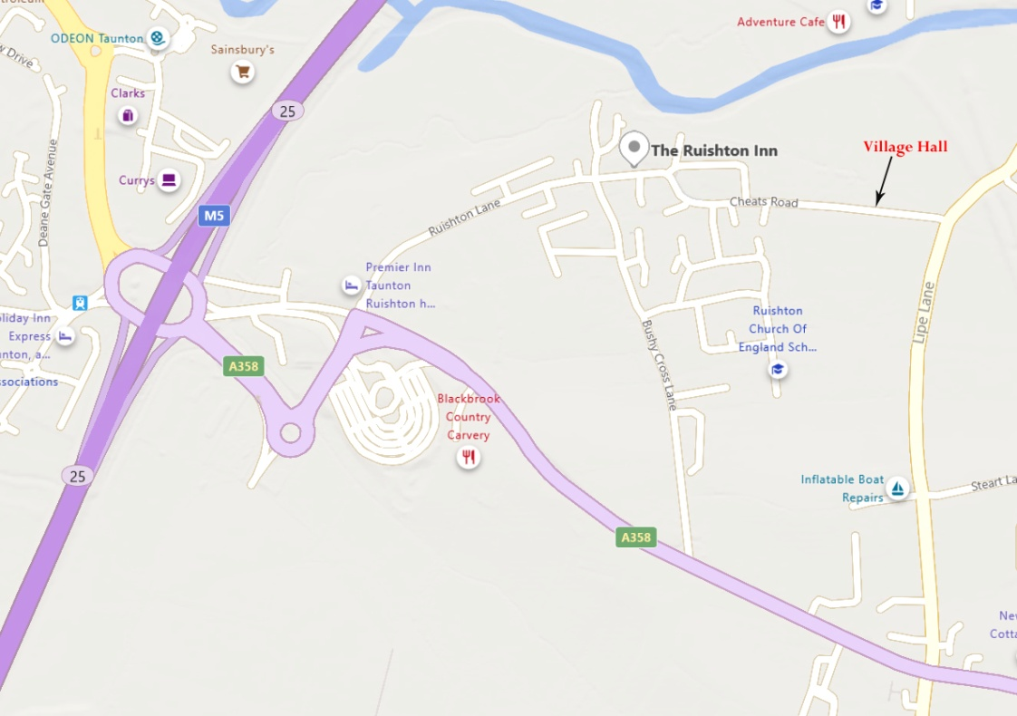

HOW TO FIND US: Ruishton Village Hall TA3 5JD
From Junction 25 of M5: take the A358 towards Ilminster.
Turn left at the first traffic lights(after large pub).
Follow this road to the Y junction by the Ruishton Inn; keep left and
continue for several hundred yards until you reach the park on your left.
The village hall is clearly visible just beyond the park.
From Ilminster: follow the A358 towards the M5. After the Thornfalcon
traffic lights, the road narrows to single lane; past the traffic camera turn
right into Lipe Lane. Follow that lane for 0.6ml then turn left into Cheats
Road. The Village Hall is a short distance up on the right.
Parking is available next to the Hall

