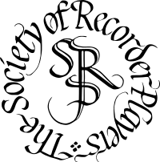
SRP Scottish Festival 2026
Master Class for Advanced Young Recorder Players
Saturday 9 May 2026, 9.30am—5pm. Master Class will be at 2pm.
Inverleith St Serf's Church Centre, 1A Clark Rd, Edinburgh EH5 3BD
By completing this booking form you agree to your details being stored on computer, for the sole purpose of managing the Festival.
First Name |  | Last Name |  | Age
Details of playing standard including recent grade exams taken and mark achieved.
School or university
Address |  |  | Post code
Email
Telephone
Name of teacher
Signature of parent/guardian if under 18 ………………………………………………………………….
Please provide details of 2 pieces of music, one of which will be selected for performance.
I can bring an accompanist with me Yes/No
Please email the completed form to anne@amartin.org.uk or return it by post, to Anne Martin, 17a, Eglinton Crescent, Edinburgh. EH12 5DD

