Playing Day with Philip Thorby Saturday June 20th@10am
Please fill in your details below
Name:
Address:
Post Code:
Tel No:
Email:
Please indicate one option:
Somerset SRP member £10.00
Visiting SRP member £16.00
Visitor £16.00
Full Time Student or
Under 18yr Free

Please download, complete and email to:- somersetsrp@gmail.com
Please pay by bank transfer to:
Society of Recorder Players Somerset Branch Sort code: 60-23-32 Acc No: 81468180 using your name as reference or by cheque made payable to: 'SRP Somerset Branch' and forward it with your application form to:
Sue Walker Kilve Cottage, 3B Maddocks Slade,
Burnham on Sea TA8 2AN
If you have any problem please contact: suewalker30@yahoo.co.uk or text 07717474917

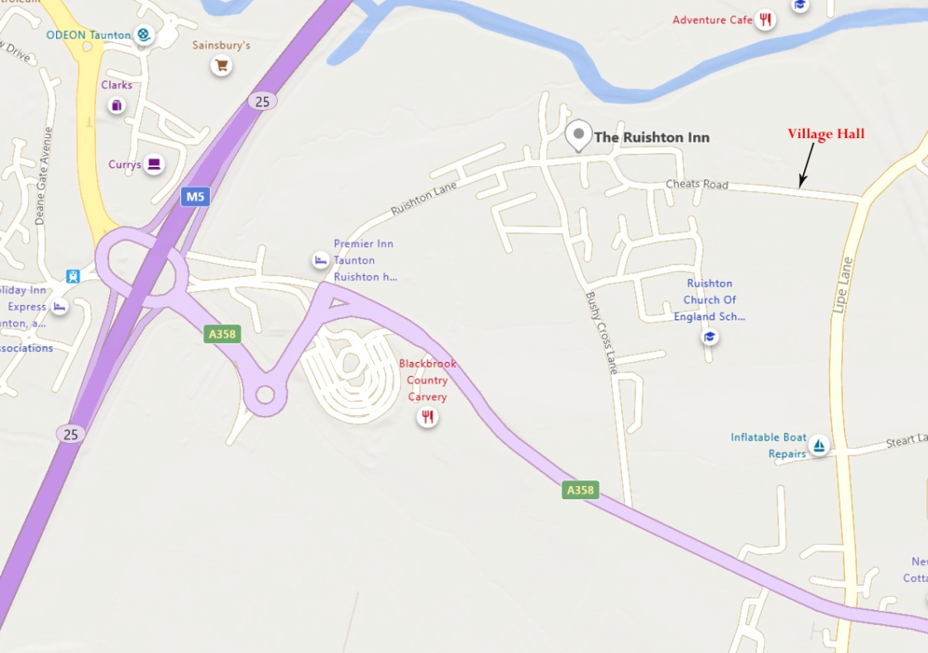
HOW TO FIND US: Ruishton Village Hall TA3 5JD
From Junction 25 of M5: take the A358 towards Ilminster. Turn left at the first traffic lights(after large pub). Follow this road to the Y junction by the Ruishton Inn; keep left and continue for a few hundred yards until you reach the park on your left.
The village hall is clearly visible just beyond the park.
From Ilminster: follow the A358 towards the M5. After the Thornfalcon traffic lights, the road narrows to single lane; past the traffic camera turn right into Lipe Lane. Follow that lane for 0.6ml then turn left into Cheats Road. The Village Hall is a short distance up on the right. Parking is available next to the Hall

